Exercise 8-3

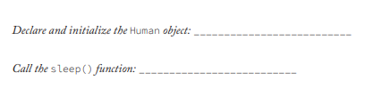

* Human human = new Human();
* human.sleep();